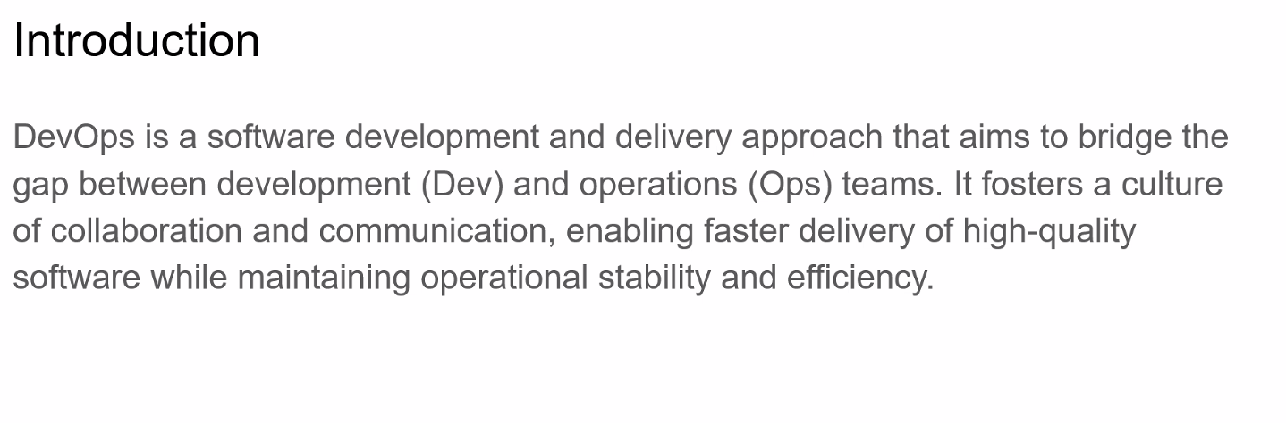

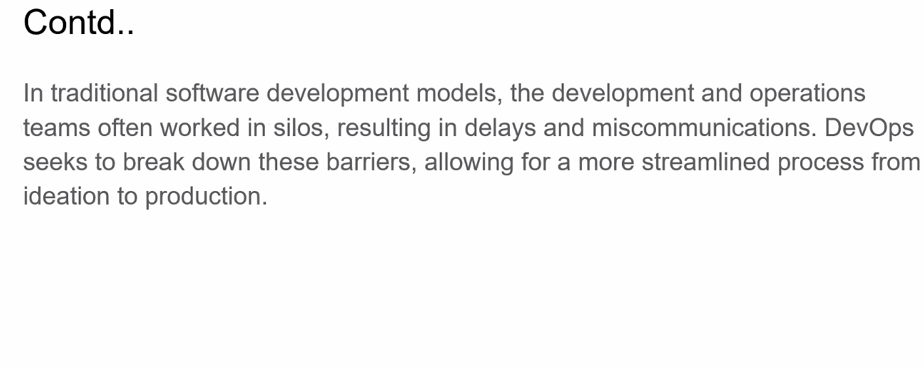

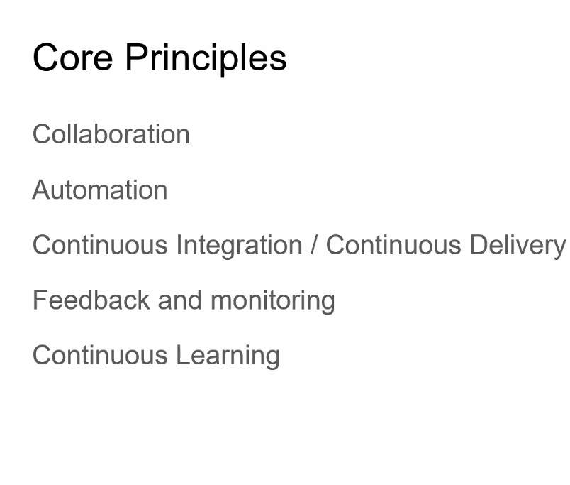

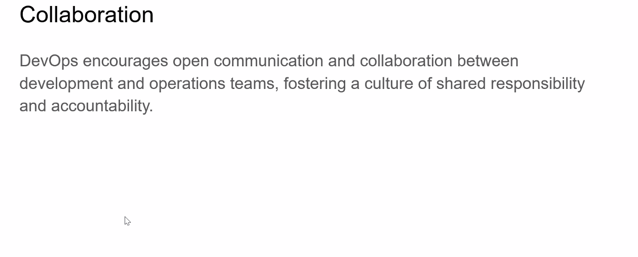

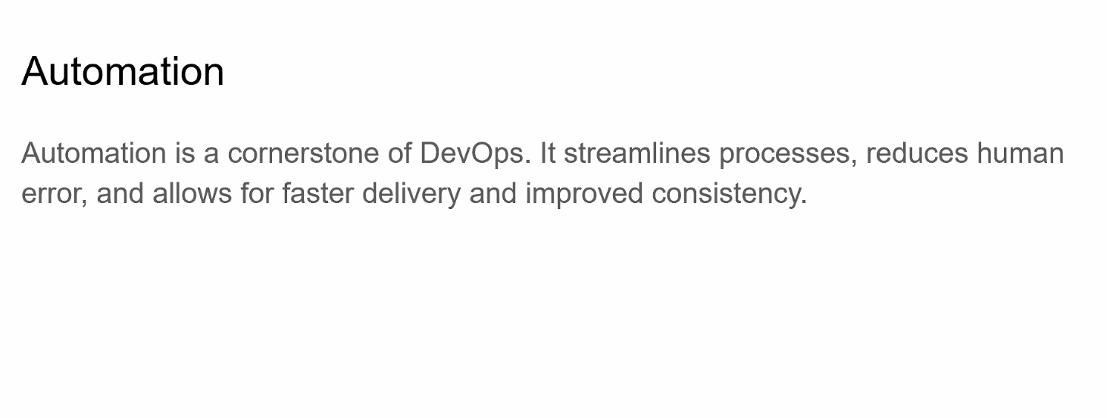

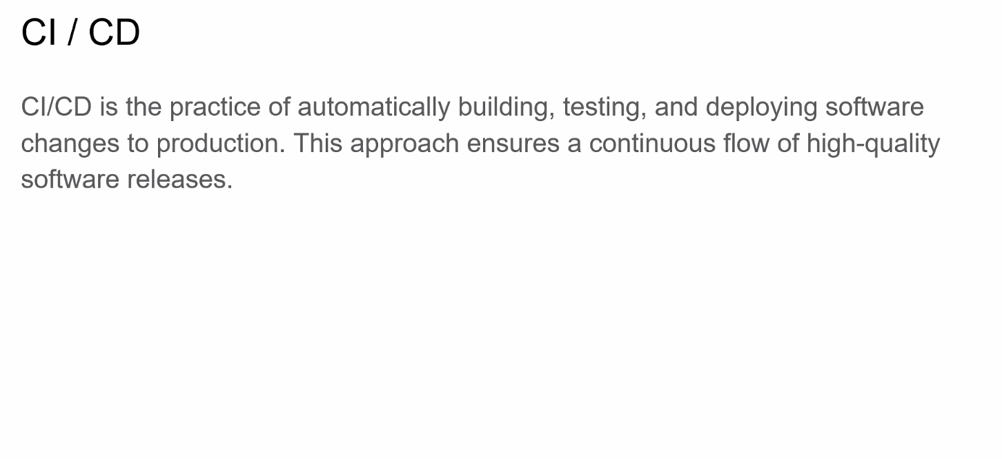

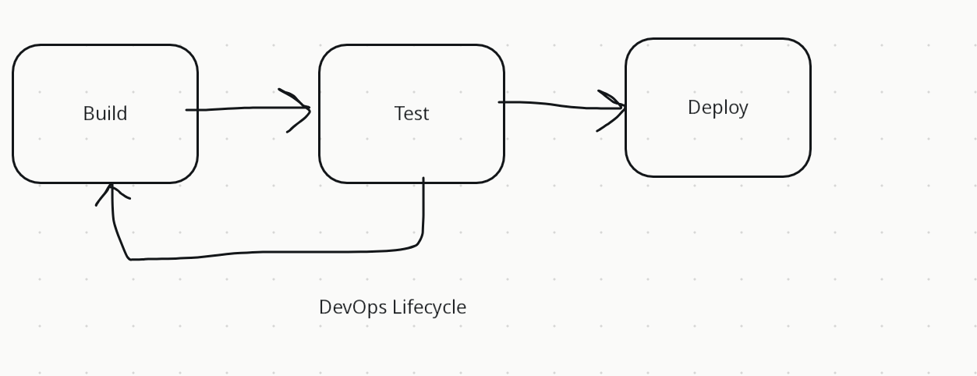

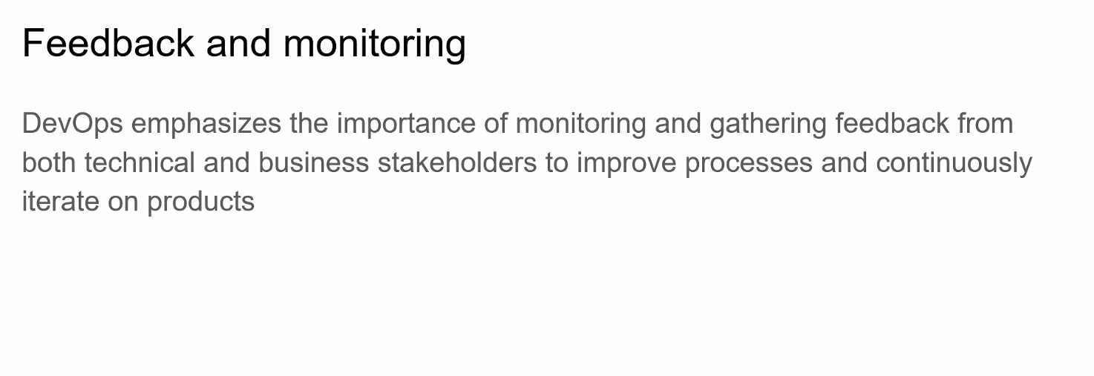

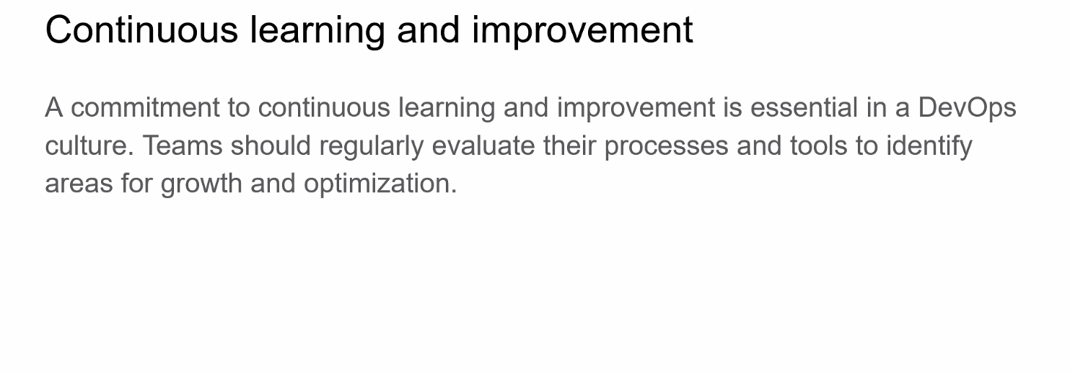

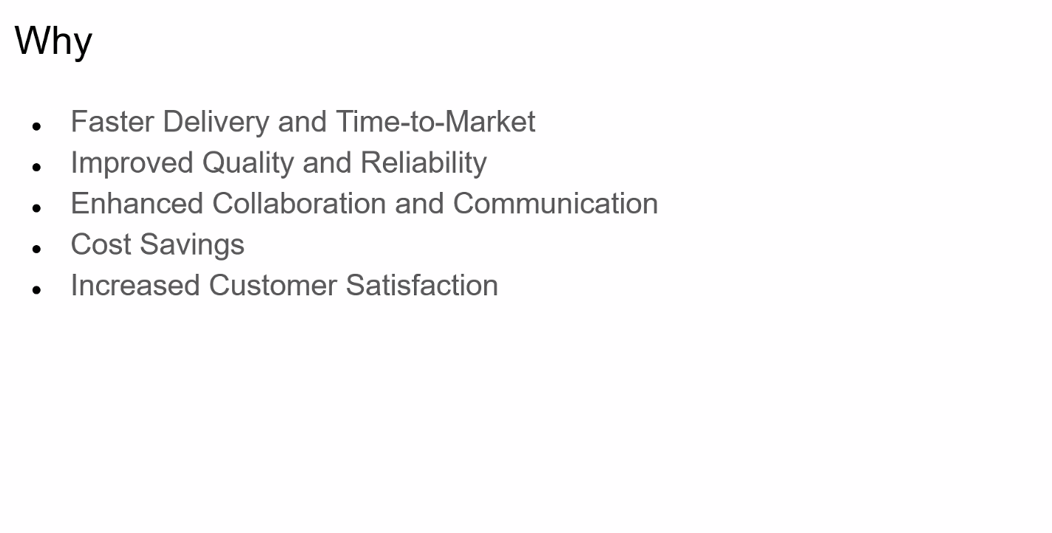

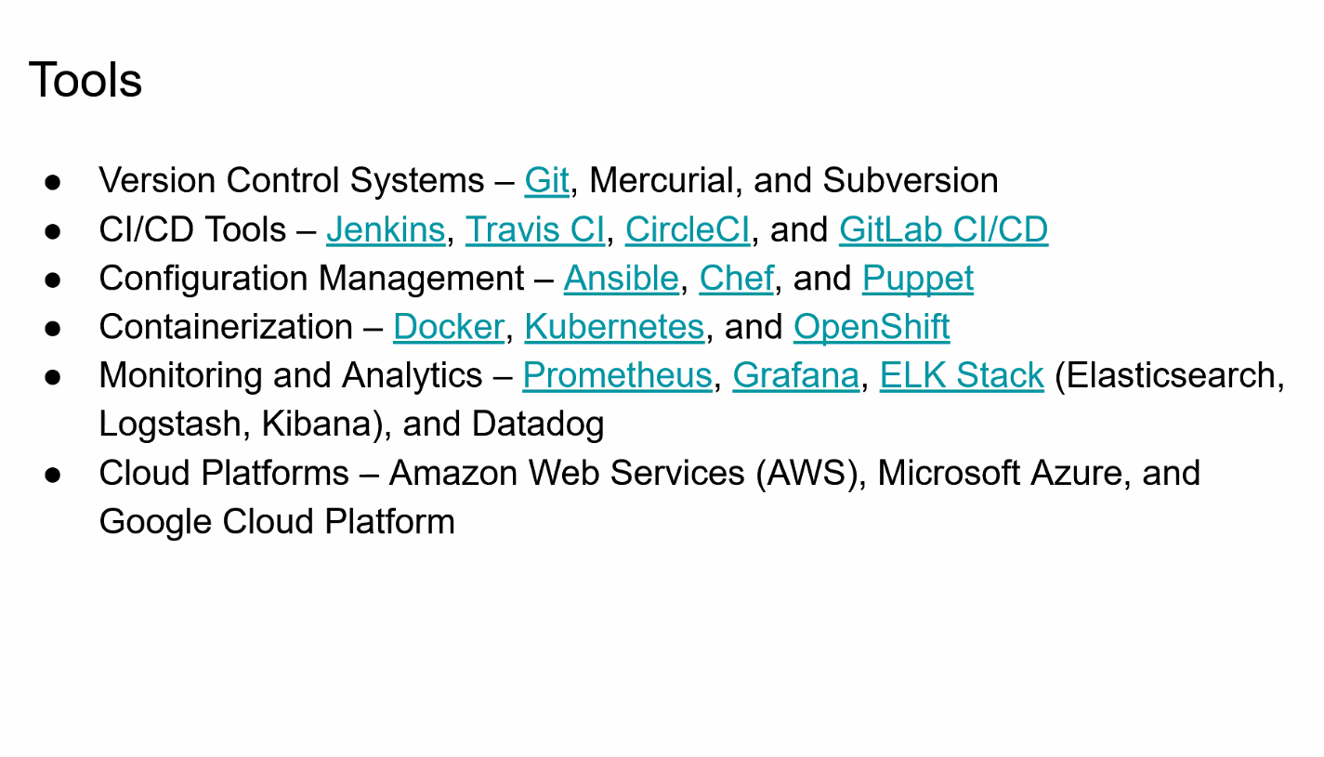

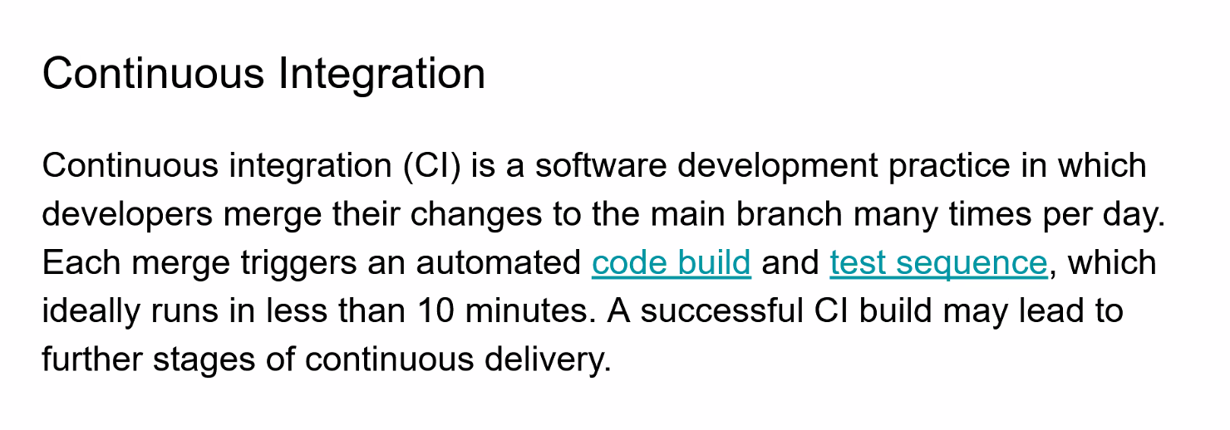

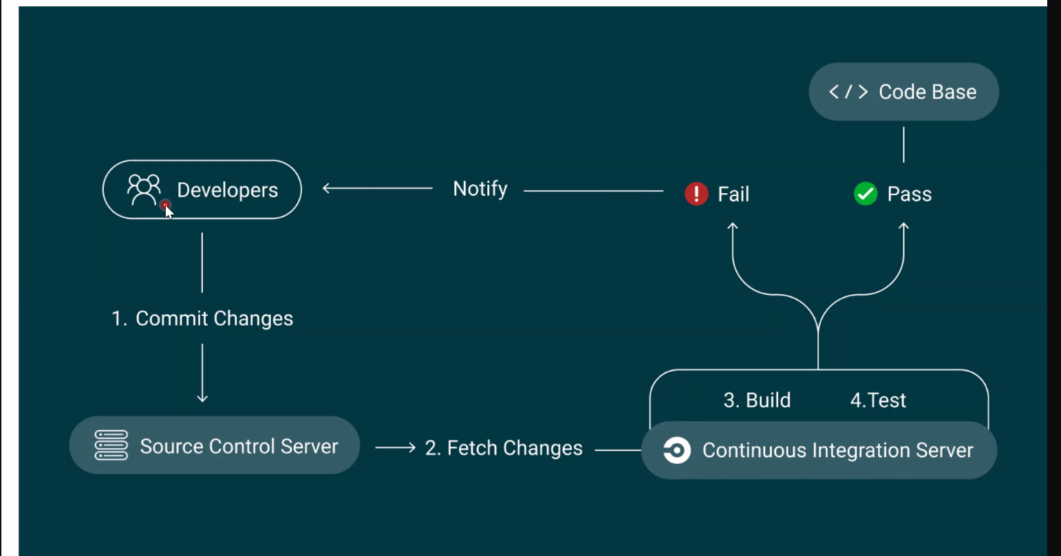

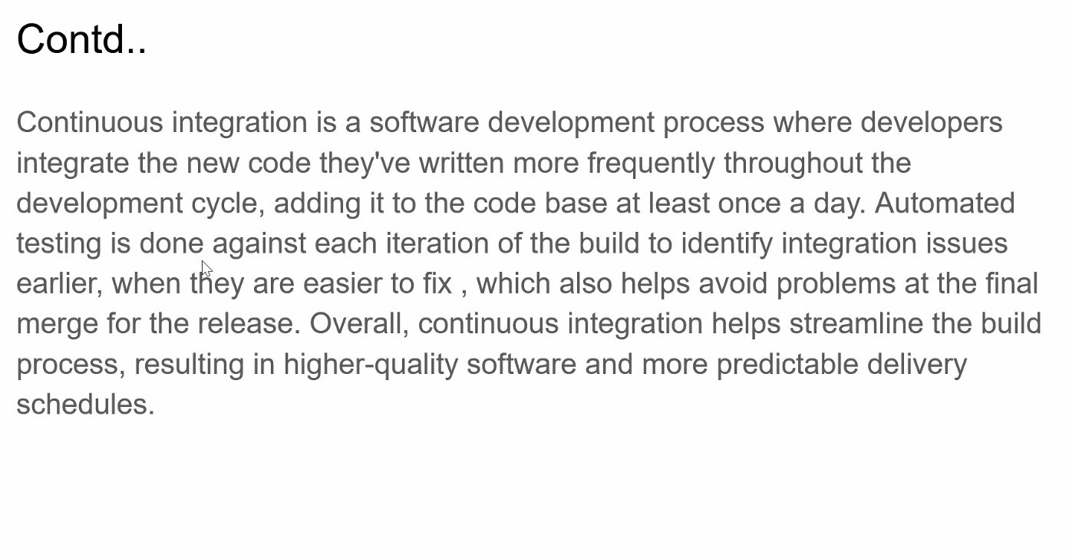

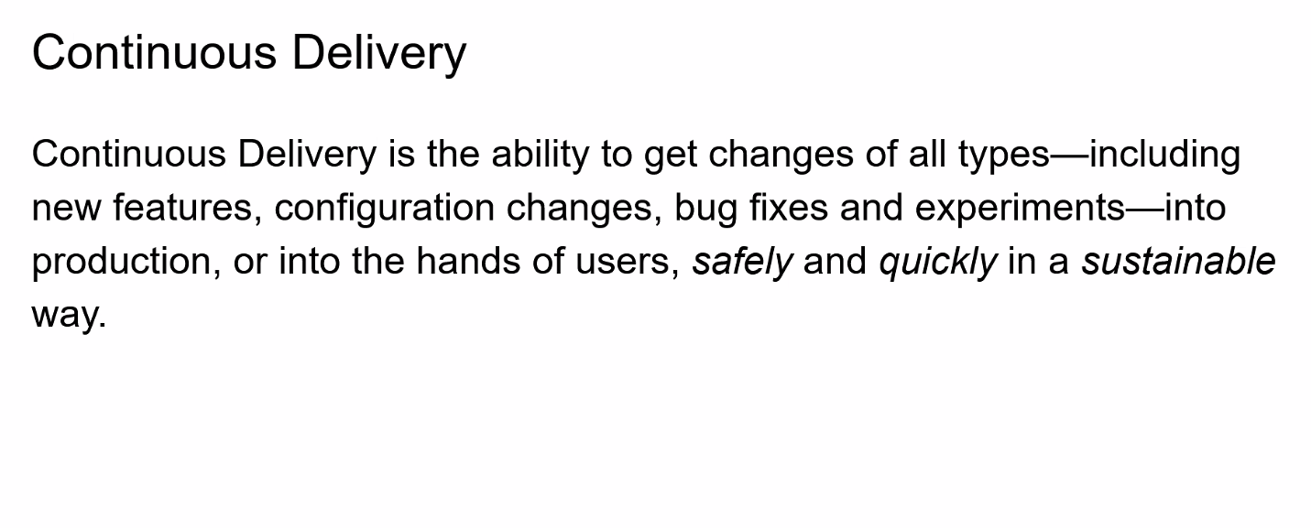

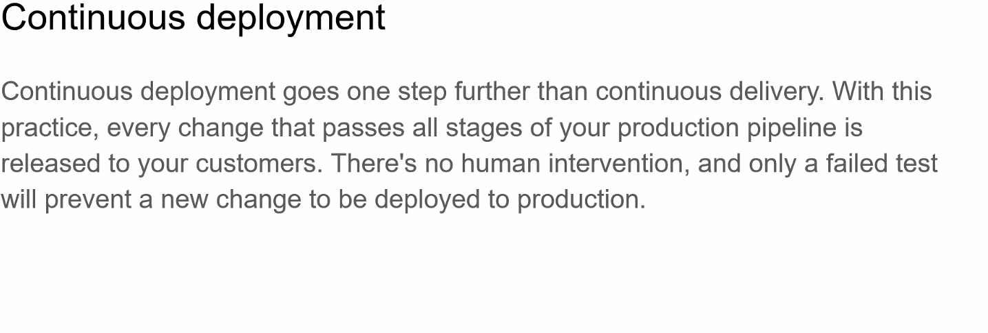

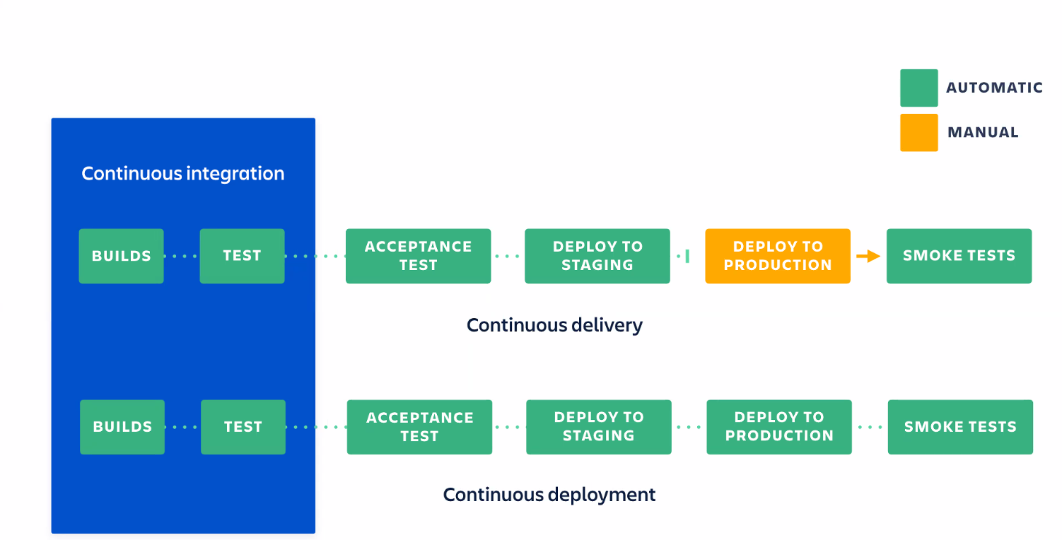

Python:

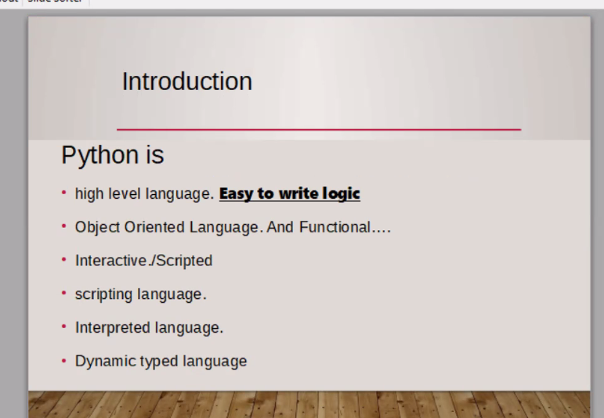

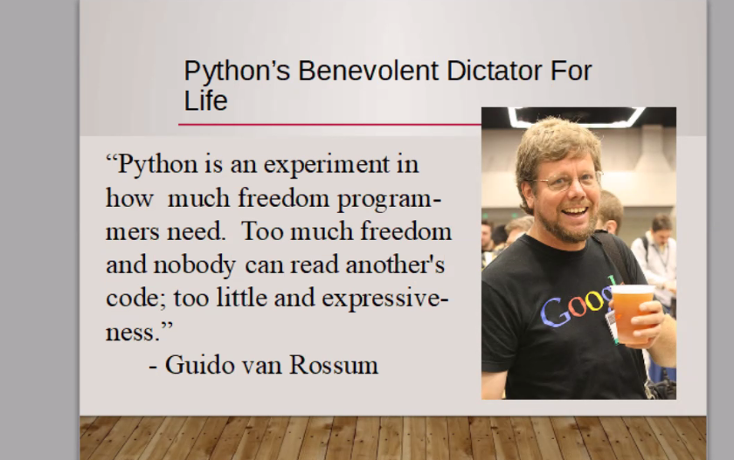

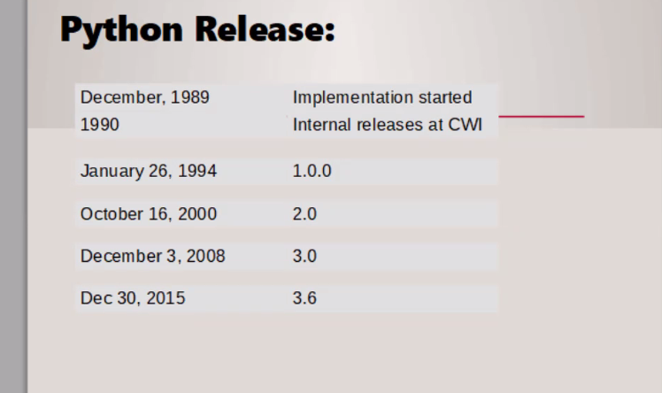

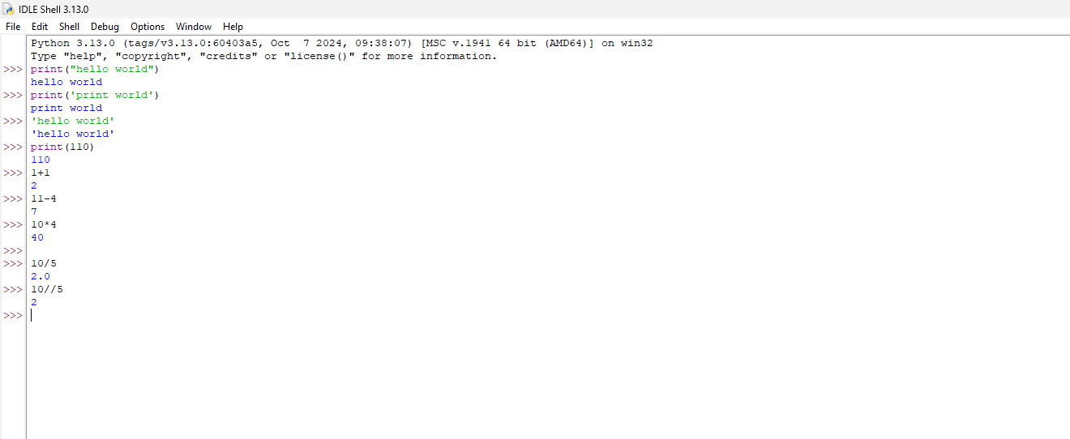

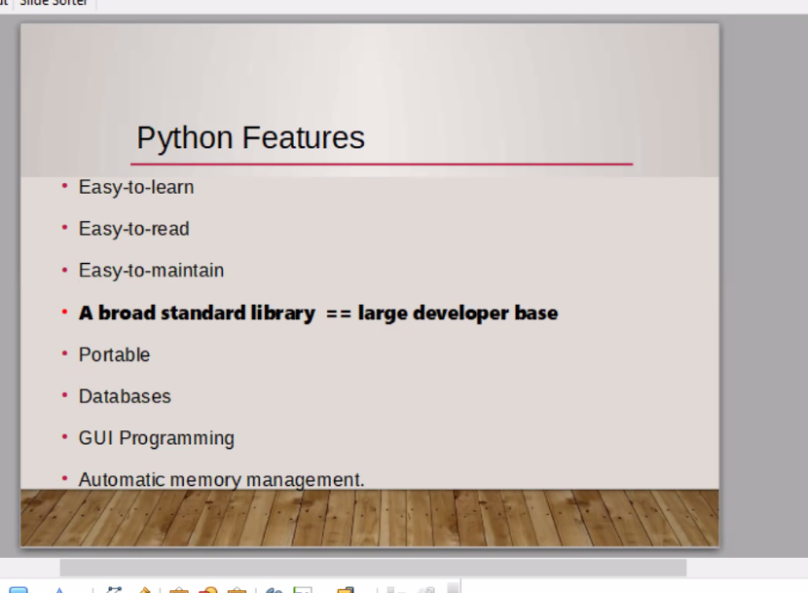

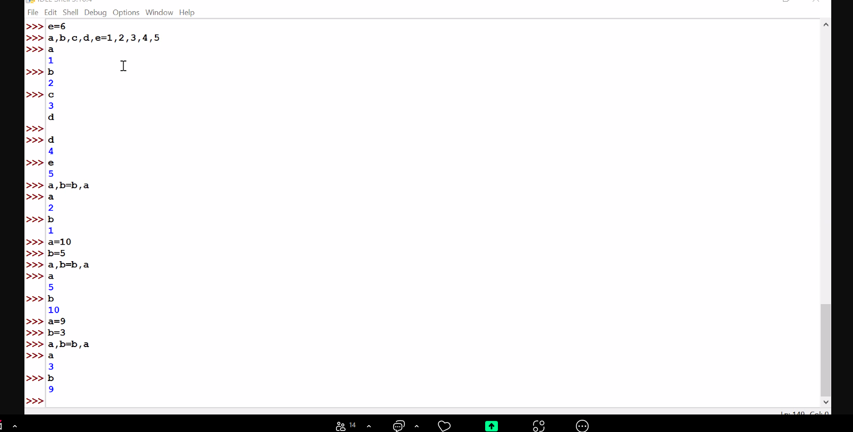

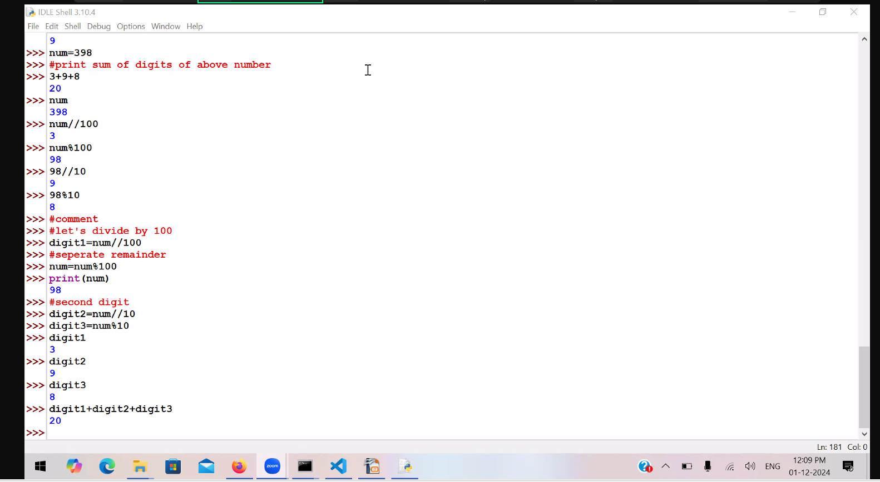

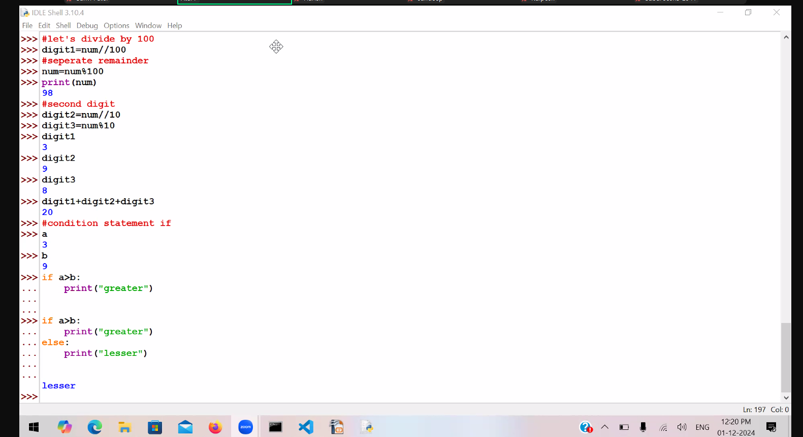

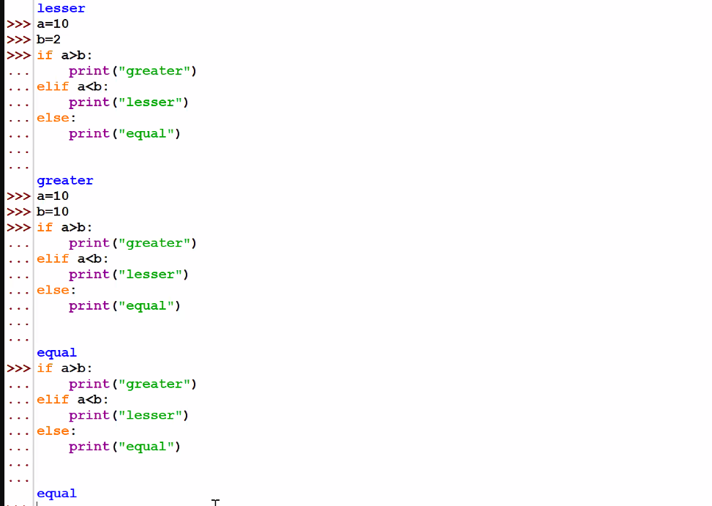

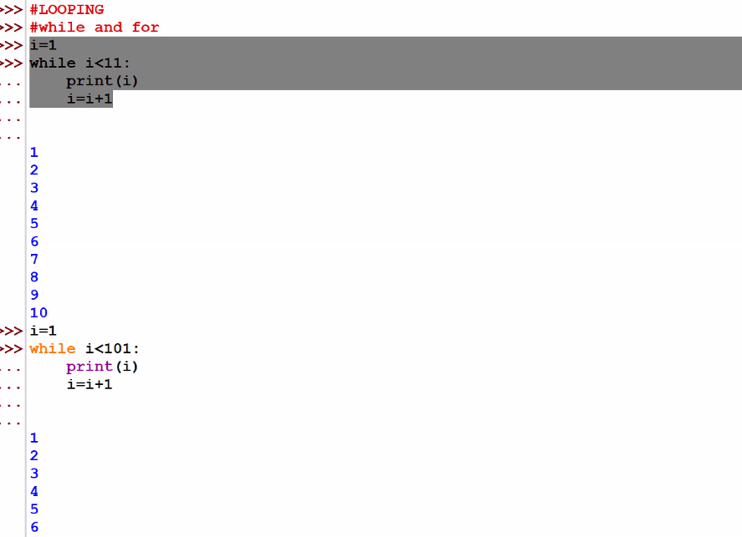

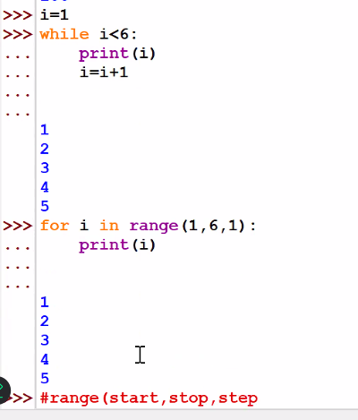

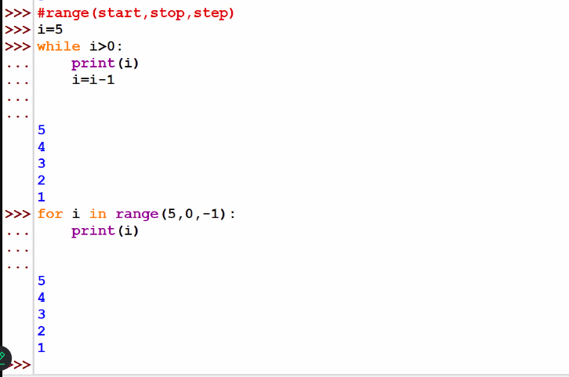

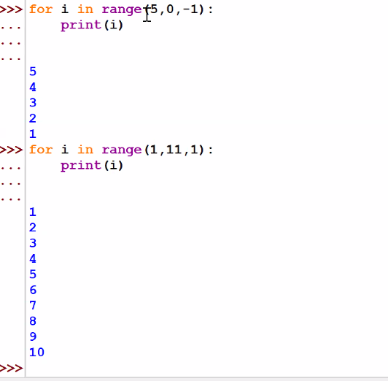

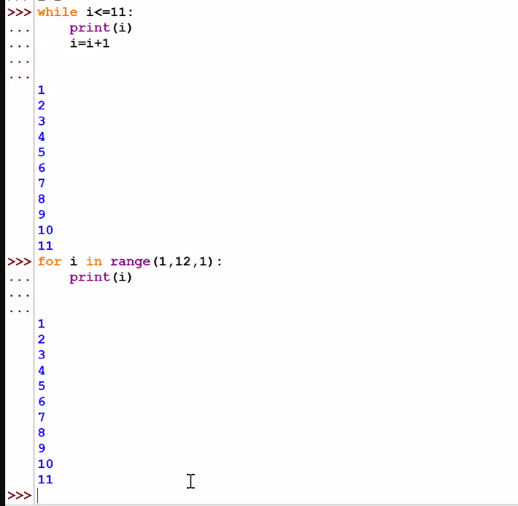

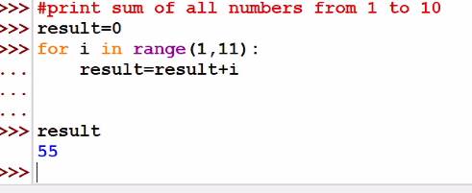

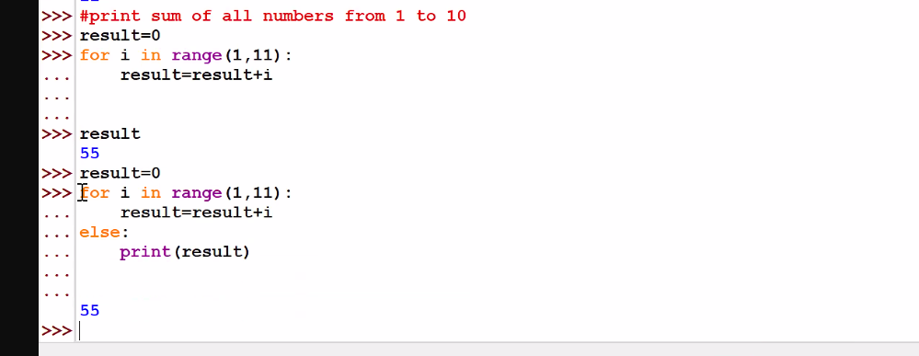

Linux:

WSL: windows subsystem for linux

ls, pwd, cd, cp, mv, touch, cat, mkdir, rm, chmod, clear

linux and shell:

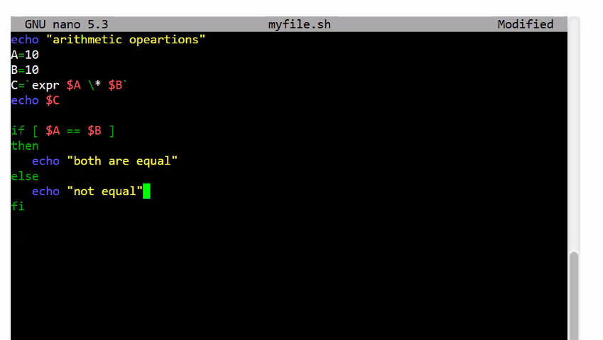

1). echo "arithmetic operations"

A=10

B=10

C=`expr $A \* $B`

echo $C

if [ $A == $B ]

then

echo "both are equal"

else

echo "not equal"

fi

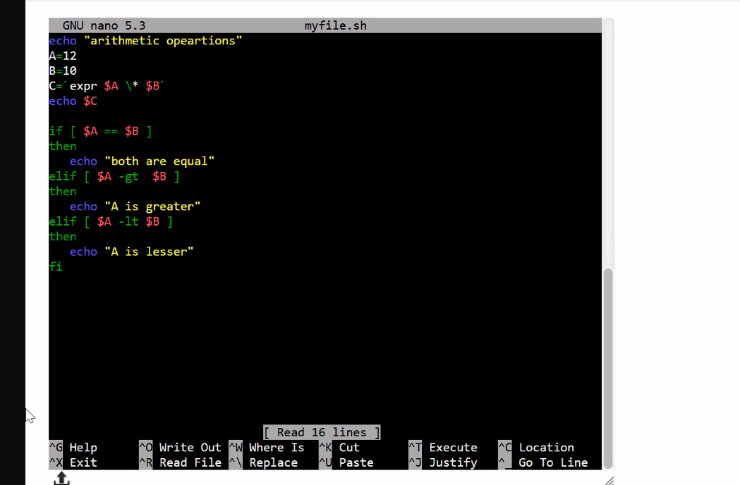

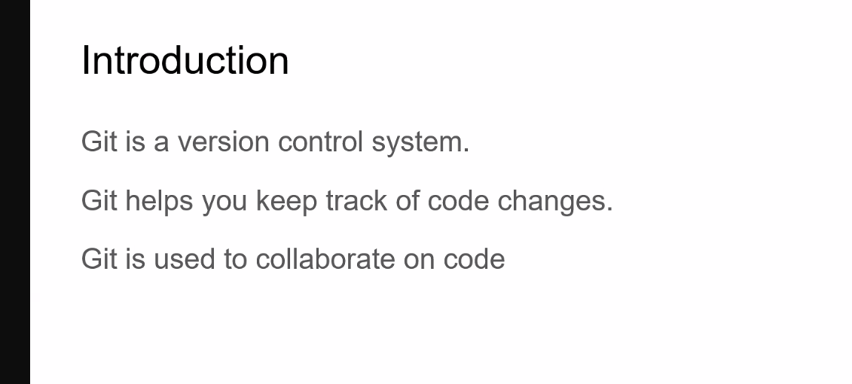

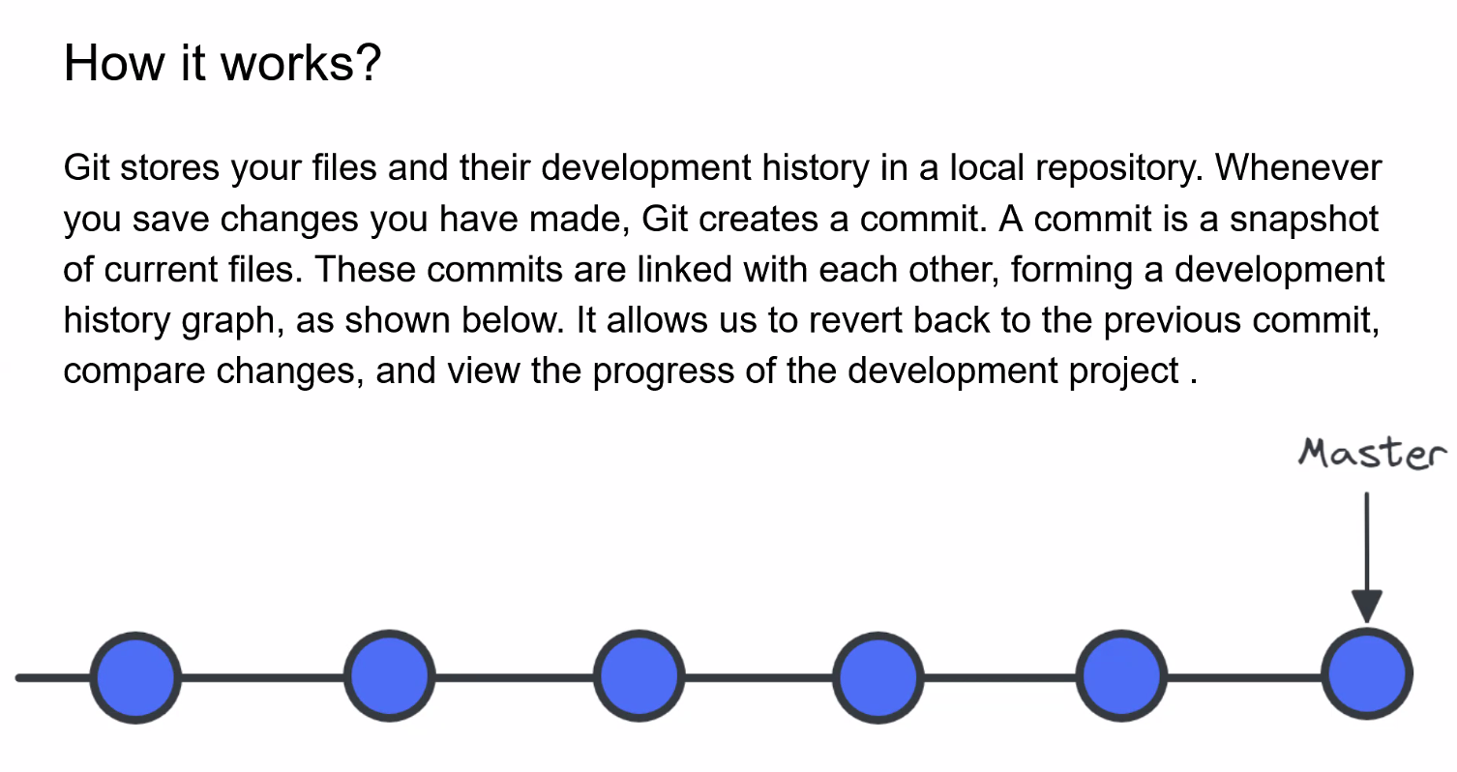

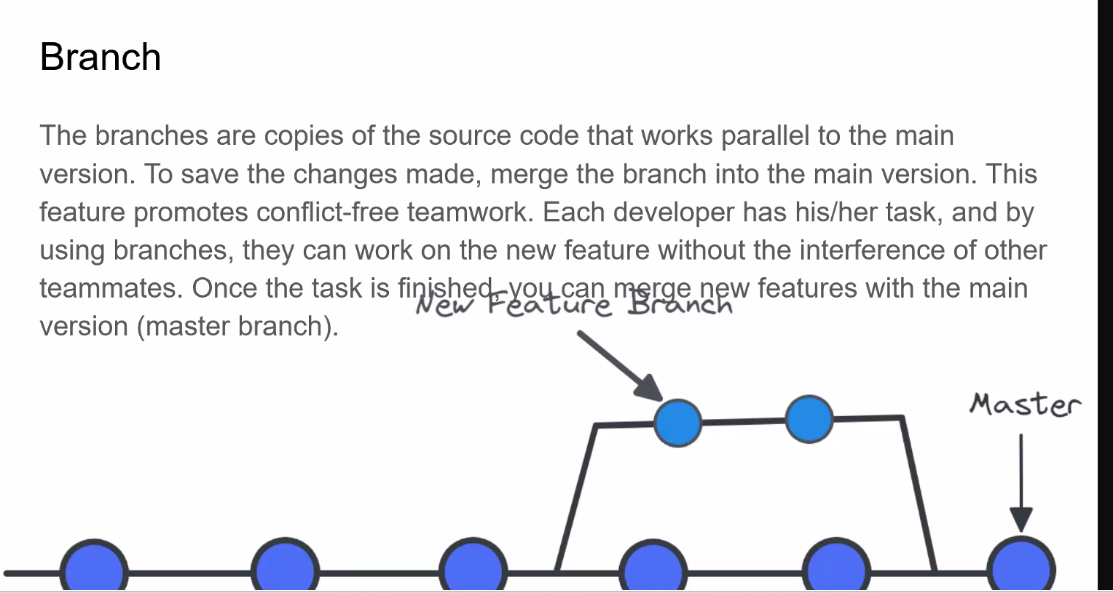

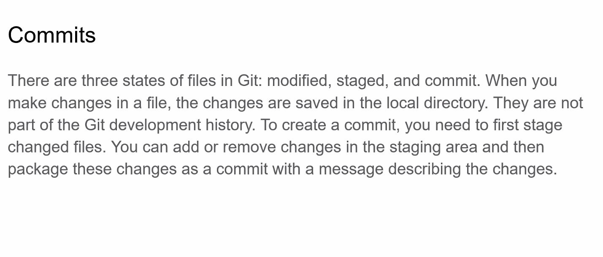

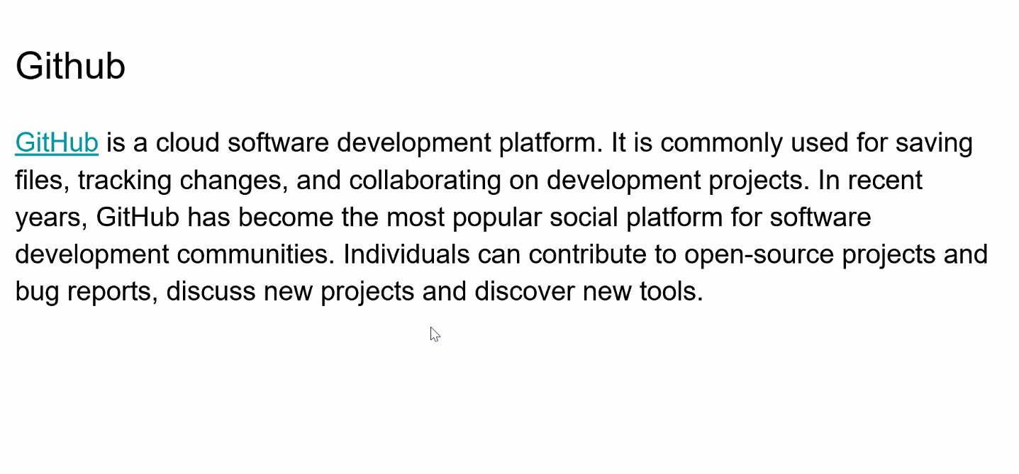

git status  
git add .  
git commit -m "write your own message"  
git pull  
git push

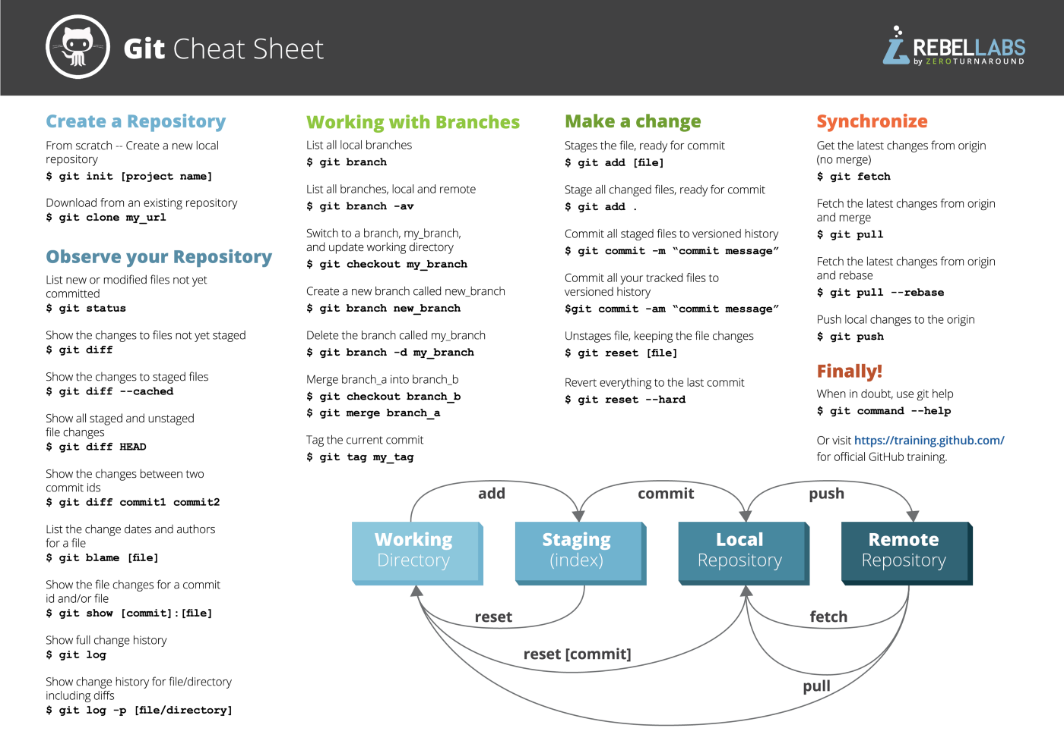

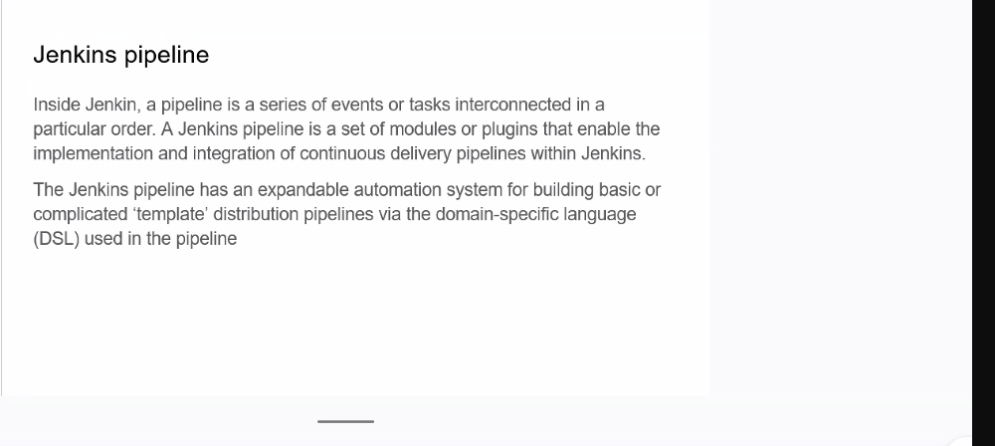

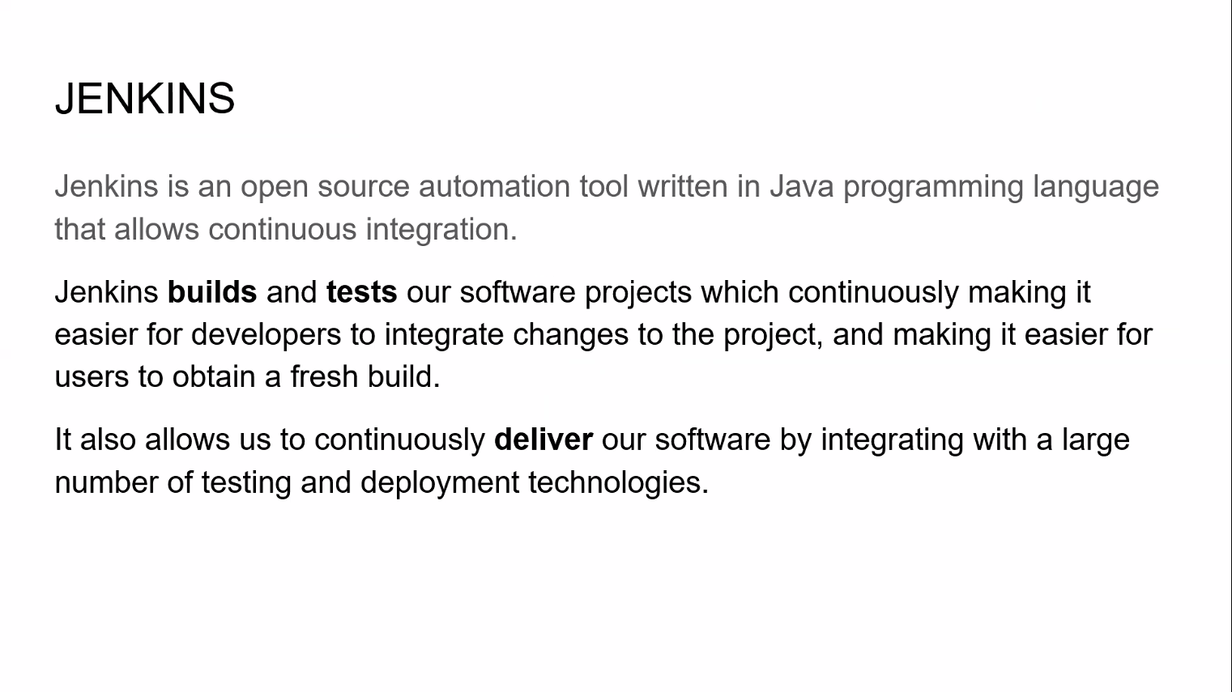

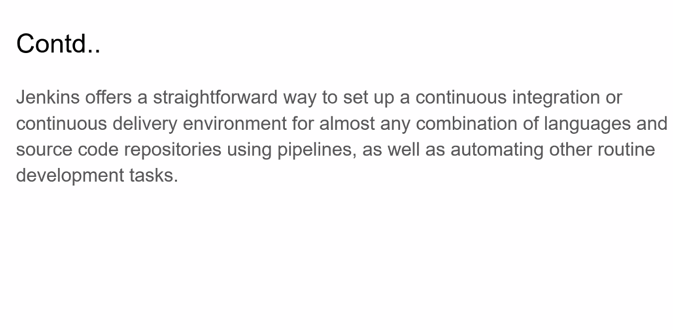

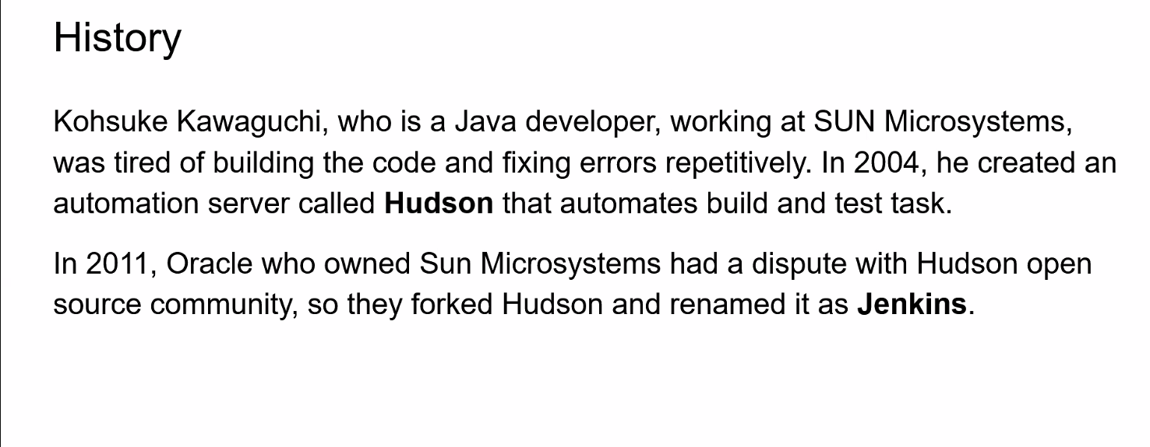

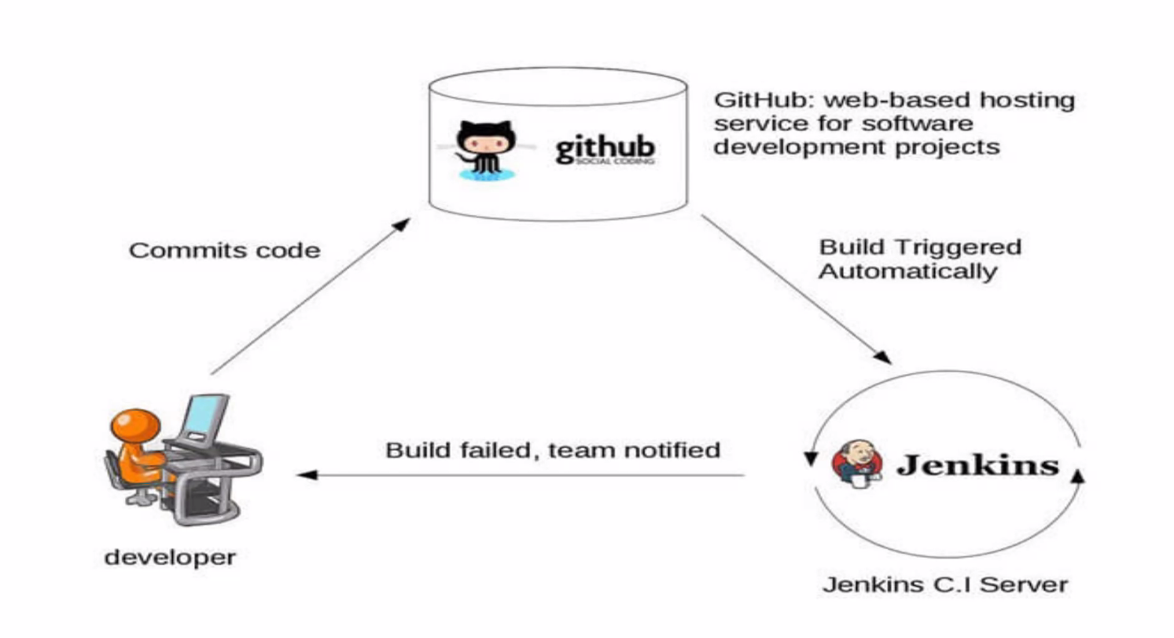

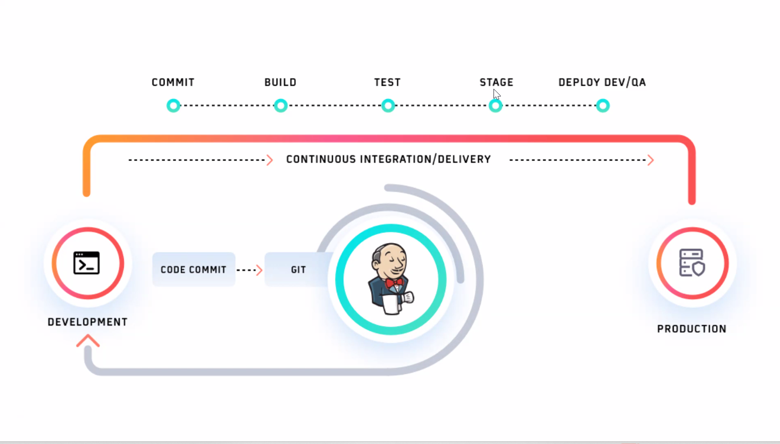

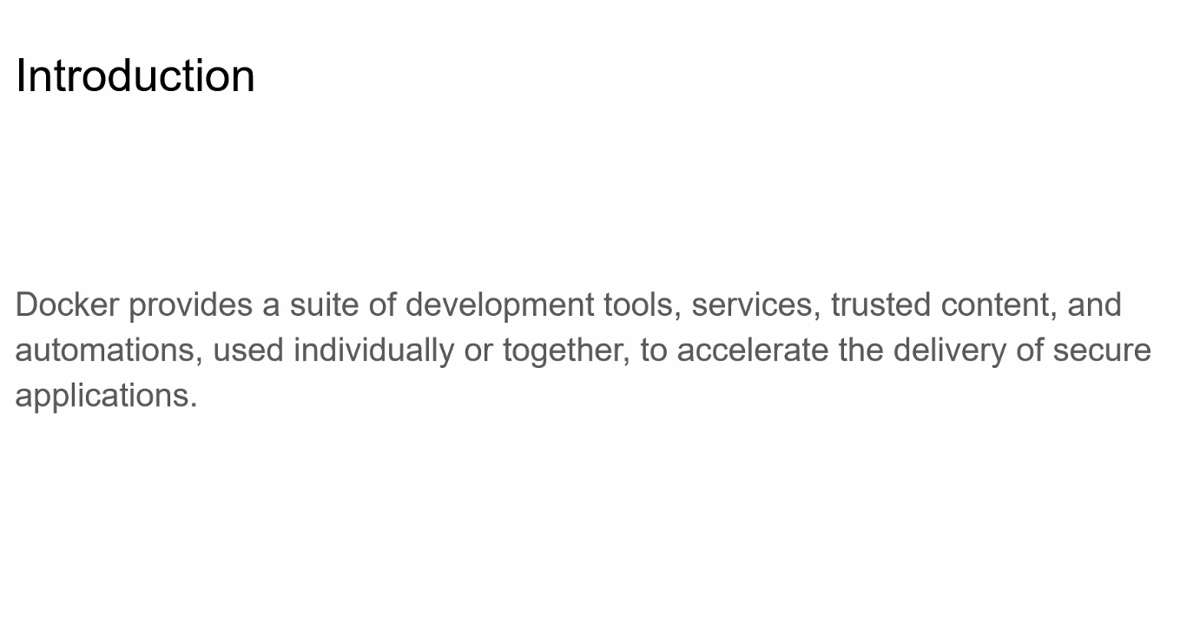

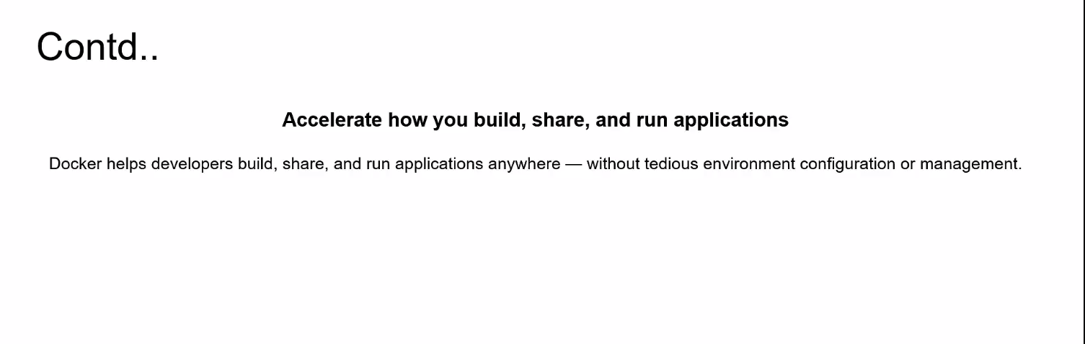

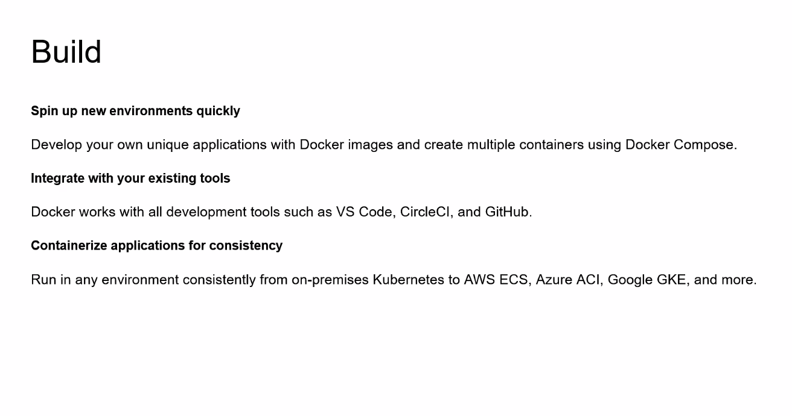

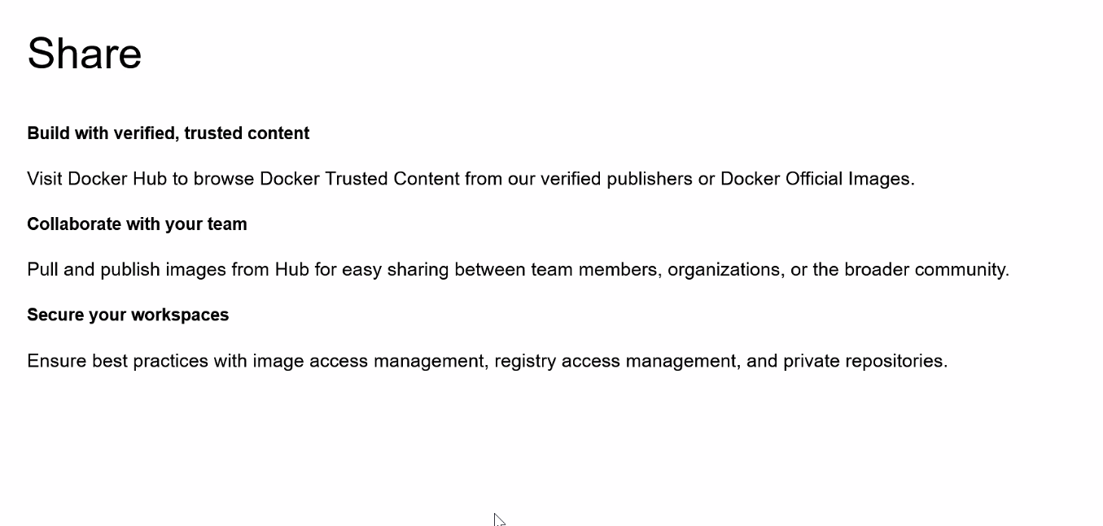

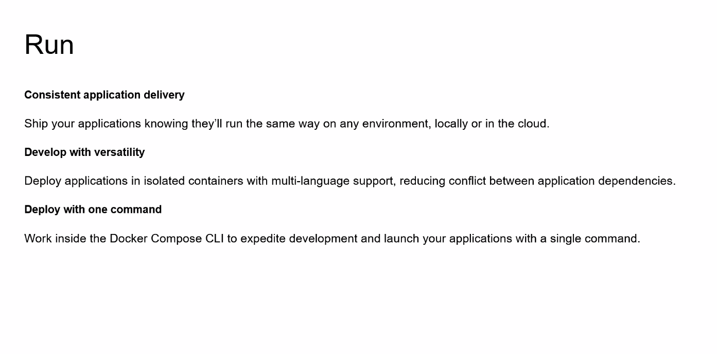

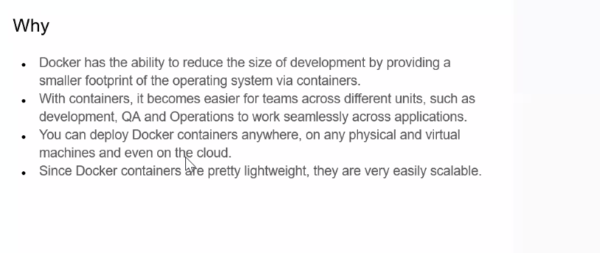

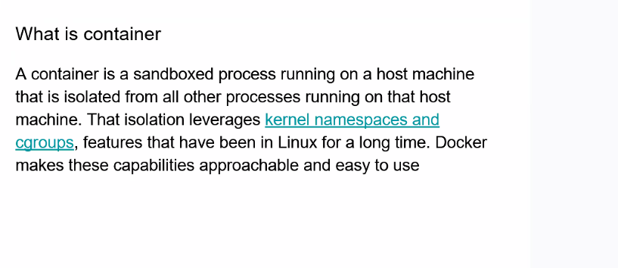

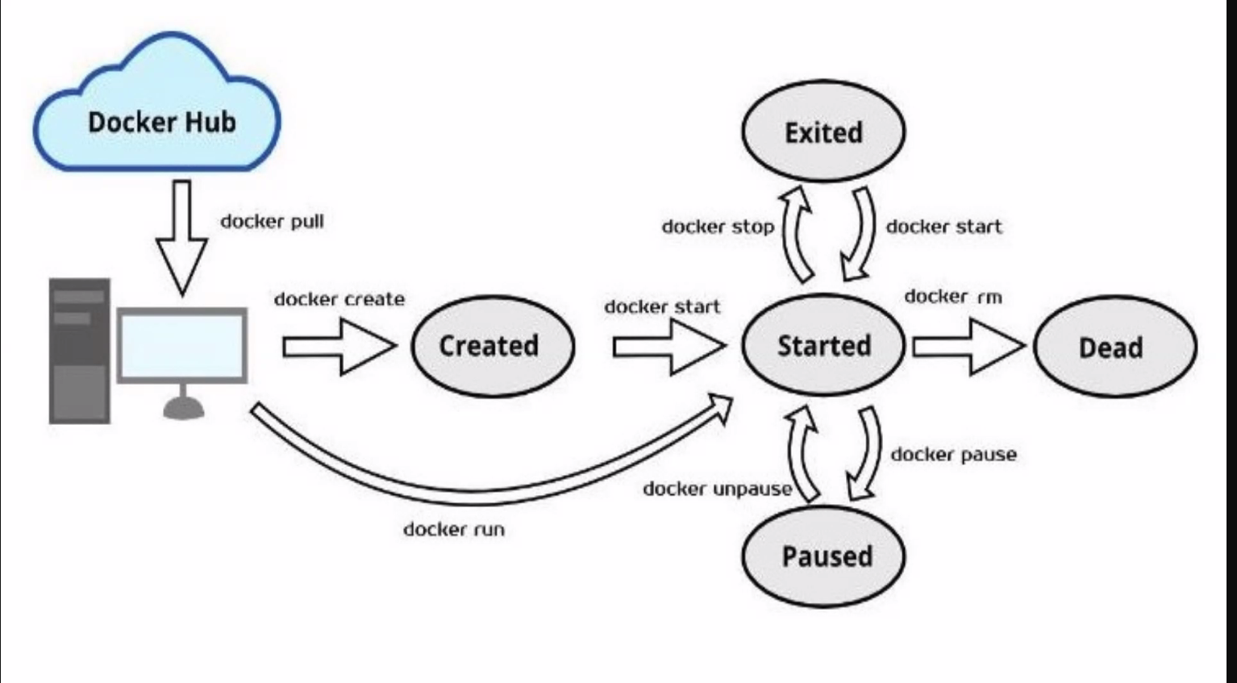

**docker cp /root/html/ myapache:/usr/share/atul/  
docker cp mynginx1:/usr/share/nginx/html/ /root/**

**docker pull  
docker run  
docker stop  
docker start  
docker ps  
docker exec  
docker images  
docker rmi <name of image>  
docker rm <name of container>  
docker logs <name of container>  
docker cp <source> <destination>**

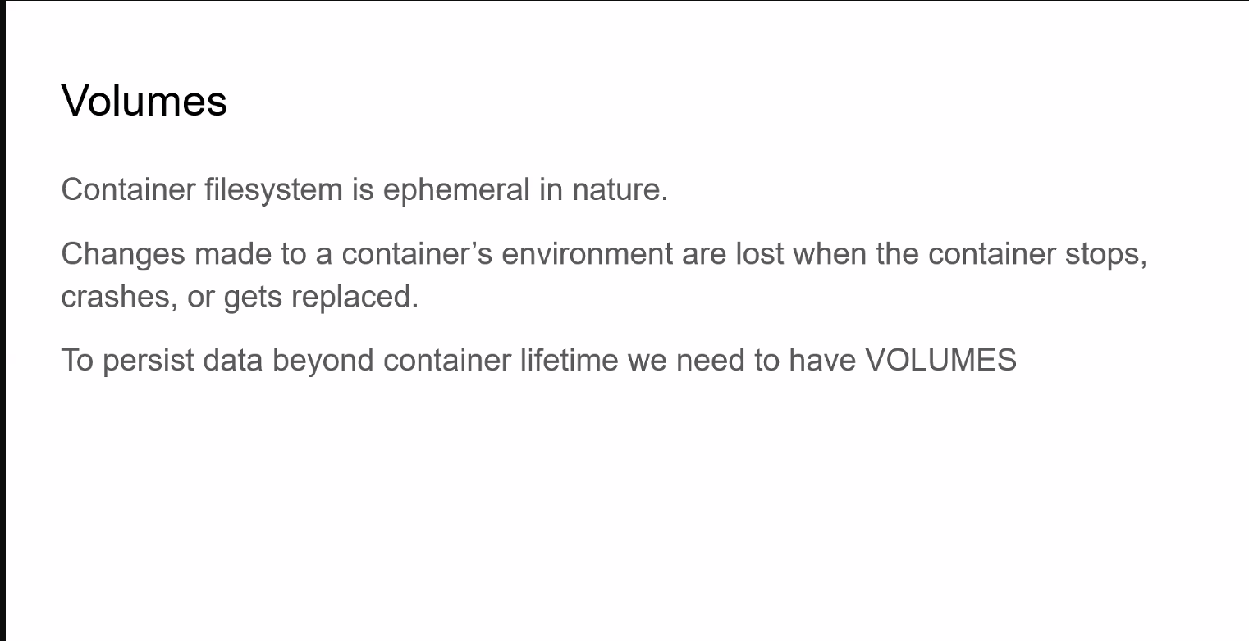

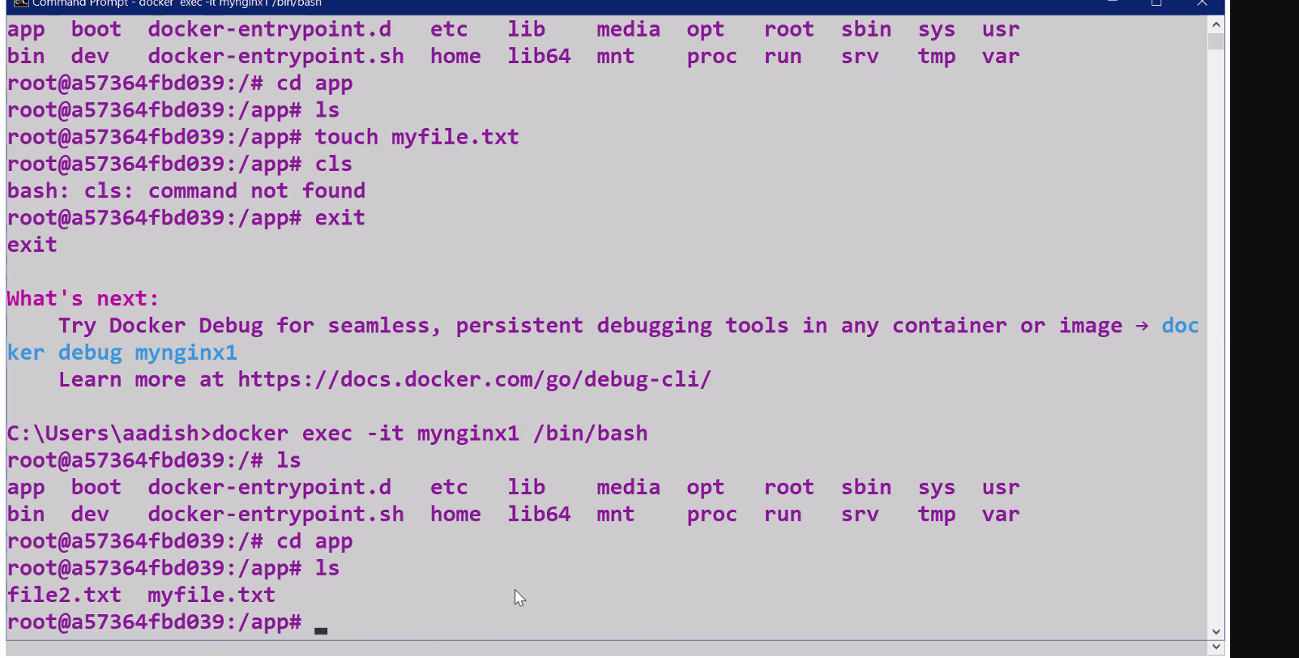



**docker volume create myvolume_demo  
docker run --name=mynginx1 -dp 8088:80 -v myvolume_demo:/app nginx**

**docker run --name=db -dp 3009:3006 -e MYSQL_ROOT_PASSWORD=root mysql**

**FROM node:latest  
WORKDIR /app  
COPY . /app  
CMD ["node", "index.js"]  
EXPOSE 3200  
  
var http=require('http')  
http.createServer(function(request,response){  
    response.end("Hello from node date is:"+new Date().toLocaleString());  
}).listen(3200);  
  
console.log("your node js app is runing on port no 3200")  
docker build -t my_node .  
docker run --name=mynode -dp 3200:3200 my_node**

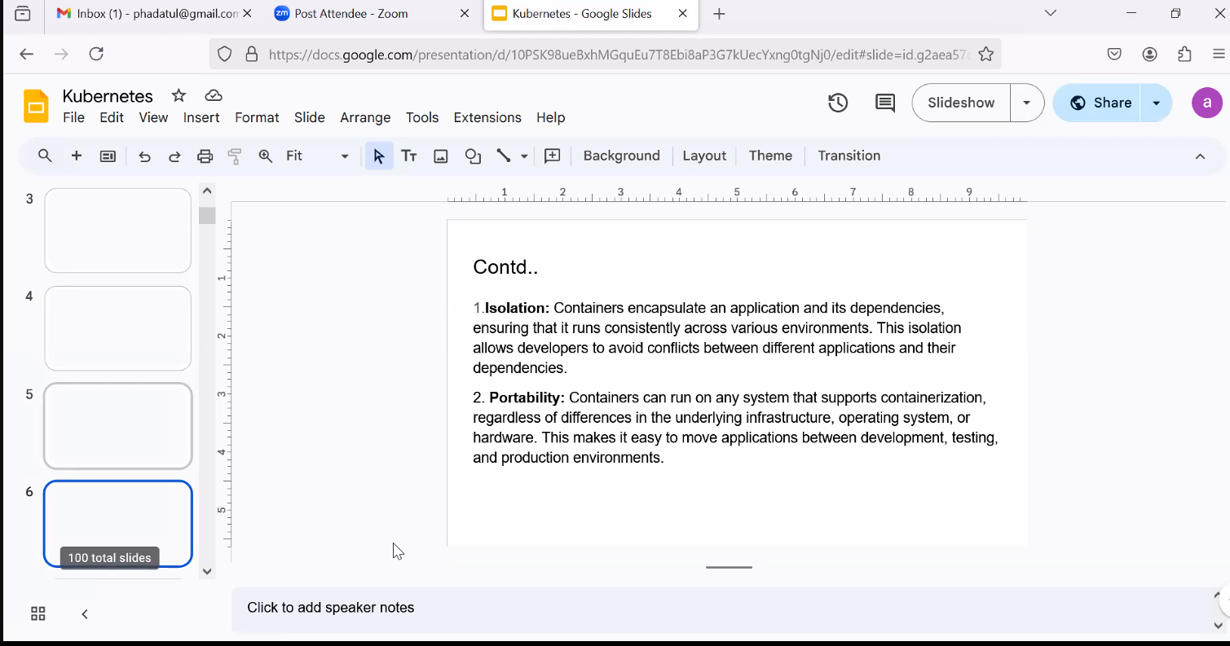

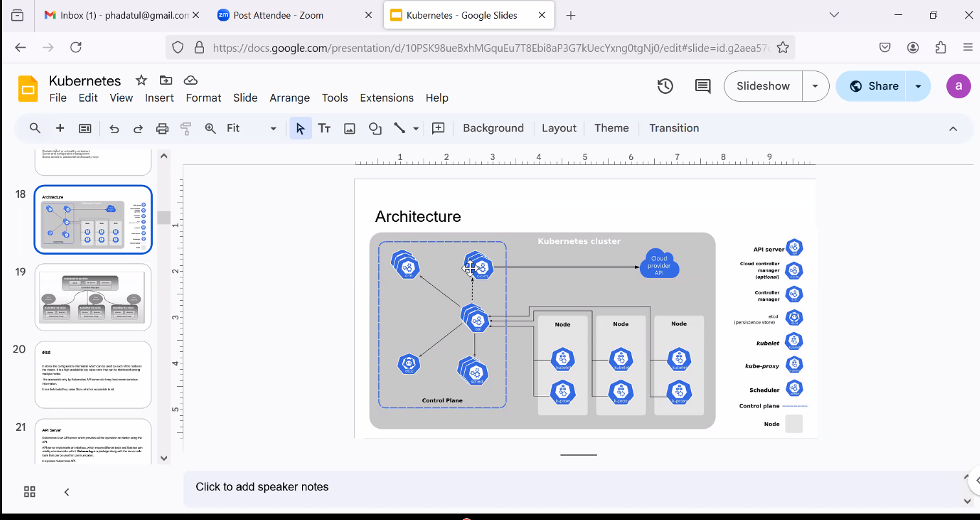

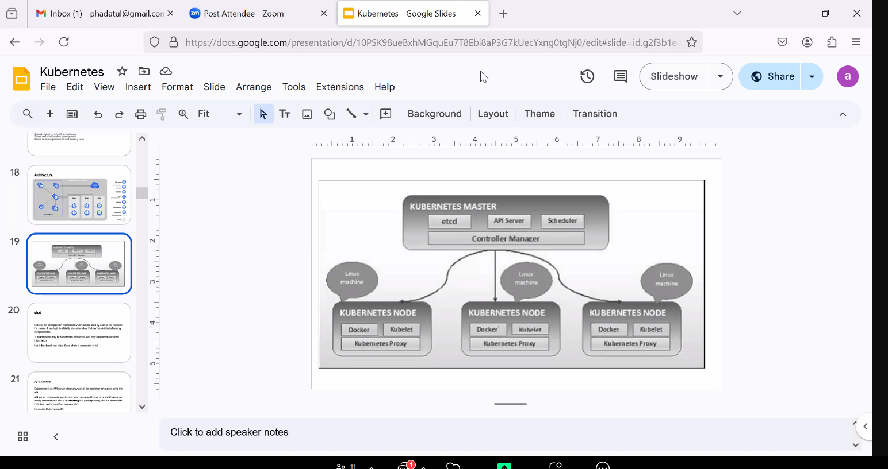

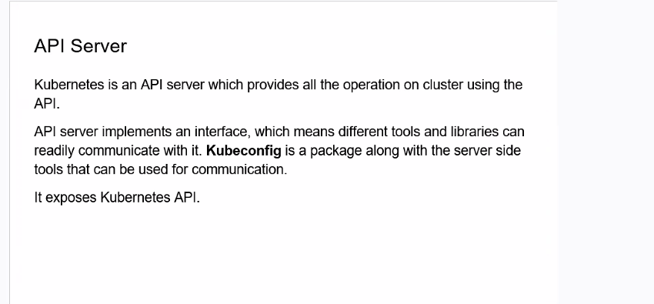

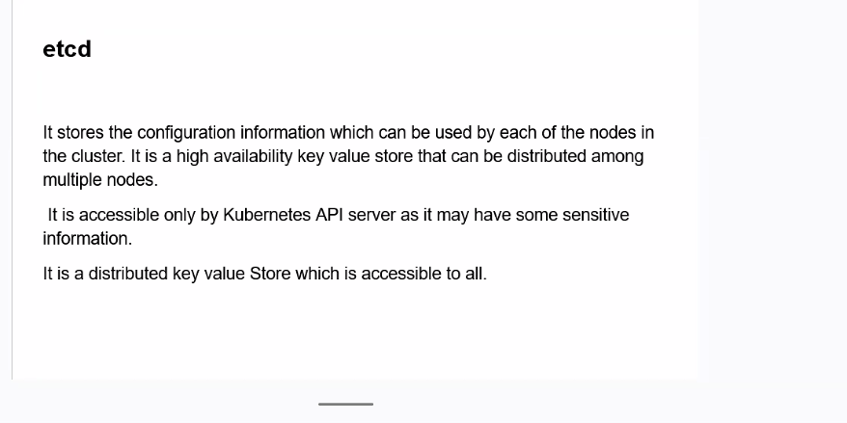

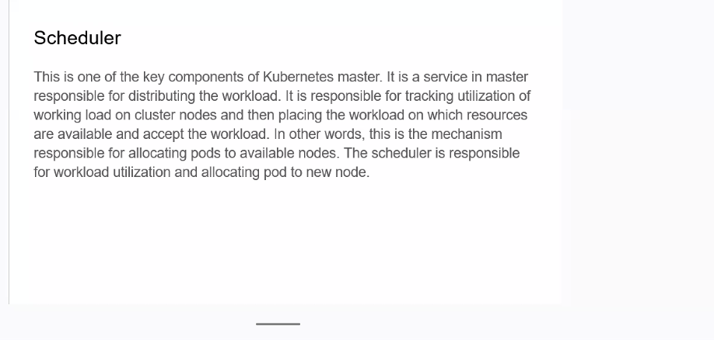

**apiVersion: v1  
kind: Pod  
metadata:  
  name: myapp  
  labels:  
    name: myapp  
    app: myapp  
spec:  
  containers:  
  - name: mynginx  
    image: nginx:latest  
    ports:  
      - containerPort: 80  
apiVersion: v1  
kind: Service  
metadata:  
  name: myservice  
spec:  
  selector:  
    app: myapp  
  ports:  
  - port: 80     *#service port*  
    targetPort: 80   *#nginx container port*  
    nodePort: 30007  *#external accessible port, range 30000-32767*  
  type: NodePort  
Abhay Desai left  
  
Atul P 12:11  
apiVersion: apps/v1  
kind: ReplicaSet  
metadata:  
     name: myreplicaset  
spec:  
   replicas: 3  
   selector:  
       matchLabels:  
            app: mynginxapp  
   template:  
       metadata:   
            name: mynginxapp  
            labels:  
                app: mynginxapp  
       spec:  
          containers:  
          - name: mynginx  
            image: nginx:latest  
Ashwini Patil left  
Kalpesh Mhatre left  
  
Atul P 12:31  
apiVersion: apps/v1  
kind: ReplicaSet  
metadata:  
  name: apachereplicaset  
  labels:  
    app: myapachereplicaset  
    environment: dev  
spec:  
  replicas: 2  
  selector:  
    matchLabels:  
      app: myapache  
  template:  
    metadata:  
      name: myapache  
      labels:  
        app: myapache  
    spec:  
      containers:  
        - name: myapache  
          image: httpd  
  
Atul P 12:48  
apiVersion: apps/v1  
kind: Deployment  
metadata:   
    name: mydeployment  
    labels:  
        app: mynginxapp  
spec:  
    replicas: 3  
    selector:  
        matchLabels:  
          app: mynginxapp  
    template:  
       metadata:  
          name: mynginxapp  
          labels:  
             app: mynginxapp  
       spec:  
         containers:  
           - name: mynginx  
             image: nginx:latest  
  
  
  
apiVersion: v1  
kind: ConfigMap  
metadata:  
  name: myconfigmap  
data:  
  MYSQL_ROOT_PASSWORD: root  
  MYSQL_USER: atul  
  MYSQL_DATABASE: demo  
  
  
Atul P 13:34  
apiVersion: v1  
kind: Pod  
metadata:  
    name: mydatabase  
    labels:  
        name: mydb   
        use: backend  
spec:  
    restartPolicy: Never  
    containers:  
      - name: mydatabase  
        image: mysql  
        env:  
        - name: MYSQL_ROOT_PASSWORD  
          valueFrom:  
            configMapKeyRef:  
                 name: myconfigmap  
                 key: MYSQL_ROOT_PASSWORD  
  
  
Atul P 13:53  
apiVersion: v1  
kind: Secret  
metadata:  
  name: mysecret  
type: Opaque  
data:  
  username: TVlTUUxfUk9PVF9QQVNTV09SRA==  
  password: cm9vdA==  
apiVersion: v1  
kind: Pod  
metadata:  
    name: mydatabase  
    labels:  
        name: mydb   
        use: backend  
spec:  
    restartPolicy: Never  
    containers:  
      - name: mydatabase  
        image: mysql  
        env:  
        - name: MYSQL_ROOT_PASSWORD  
          valueFrom:  
            secretKeyRef:  
                 name: mysecret  
                 key: password**



